😮‍💨 Reviewer for Life

WEEK 1: REGIONAL LITERATURE IN ENGLISH

I. DEFINITION
- Regional Literature in English refers to literary works written in the English language that reflect the culture, traditions, beliefs, dialects, environment, and social realities of a specific geographic region.
- It highlights the local color, identity, and experiences of people from a particular province, state, or community while using English as the medium of expression.

EXAMPLE
Muslim (Libing & Marriage)

II. KEY CHARACTERISTICS

Strong Sense of Place
- Detailed description of landscapes, climate, and local environment.
- Setting plays an important role in the story.
Note: You need to adapt

EXAMPLE
Langgam in Bisaya is lumilipad

Local Culture and Traditions
- Customs, rituals, festivals, and belief systems are emphasized.
- Shows unique cultural identity.

EXAMPLE
Aswang, Mambabarang/Nakulam (Tawas), Popcorn ni sir T^T

Focus on Everyday Life
- Depicts ordinary people and their struggles.
- Often explores rural or provincial life.

EXAMPLE
Lifestyle in province

Social Issues
May address poverty, migration, gender roles, colonial influence, or modernization.

III. PURPOSE OF REGIONAL LITERATURE
- To preserve and promote local culture
- To give voice to marginalized or underrepresented communities.
- To document regional history and traditions.
- To promote cultural pride and identity.
- To show diversity within a nation.

EXAMPLE
El Fili and Noli Me, Diversity

WEEK 2: BIAG NI LAM-ANG

Overview of the Literary Work
- Biag ni Lam-ang is a pre-colonial epic from the Ilocos Region in the Philippines.
- It is one of the most famous examples of Philippine folk epics written in Ilocano.
- The earliest written version was recorded by Pedro Bucaneg, known as the “Father of Ilocano Literature.”

It reflects:
- Heroism and bravery
- Family loyalty
- Courtship and marriage traditions.
- Supernatural beliefs
- Cultural values of the Ilocano people.

Background of the Epic
Region: Ilocos
Genre: Epic (Folk Epic)
Language: Ilocano
Time Period: Pre-colonial Philippines
Theme: Heroism, Love, Revenge, Supernatural Power

Background of the Epic
- Lam-ang – The epic hero with supernatural strength
- Ines Kannoyan – His beautiful wife
- Don Juan – Lam-ang’s father
- Namongan – Lam-ang’s mother
- Saridandan – Magical rooster
- Berkakan – Giant Fish

Summary of the Story

Birth of Lam-ang
Lam-ang was born with the ability to speak immediately after birth. He chose his own name and was already intelligent and strong.

Search for His Father
His father, Don Juan, was killed by the Igorot tribe. At a young age, Lam-ang went on a journey to avenge his father. He defeated the Igorots and returned home victorious.

Courtship of Ines Kannoyan
Lam-ang fell in love with Ines Kannoyan. To win her hand, he performed heroic deeds and impressed her parents with his wealth and bravery.

Death and Resurrection
During a fishing trip, Lam-ang was eaten by a giant fish (Berkakan). Through the help of his magical pet rooster and dog, he was brought back to life.

Goodluck folks!

Copy of W2
Definition of Literature / Background

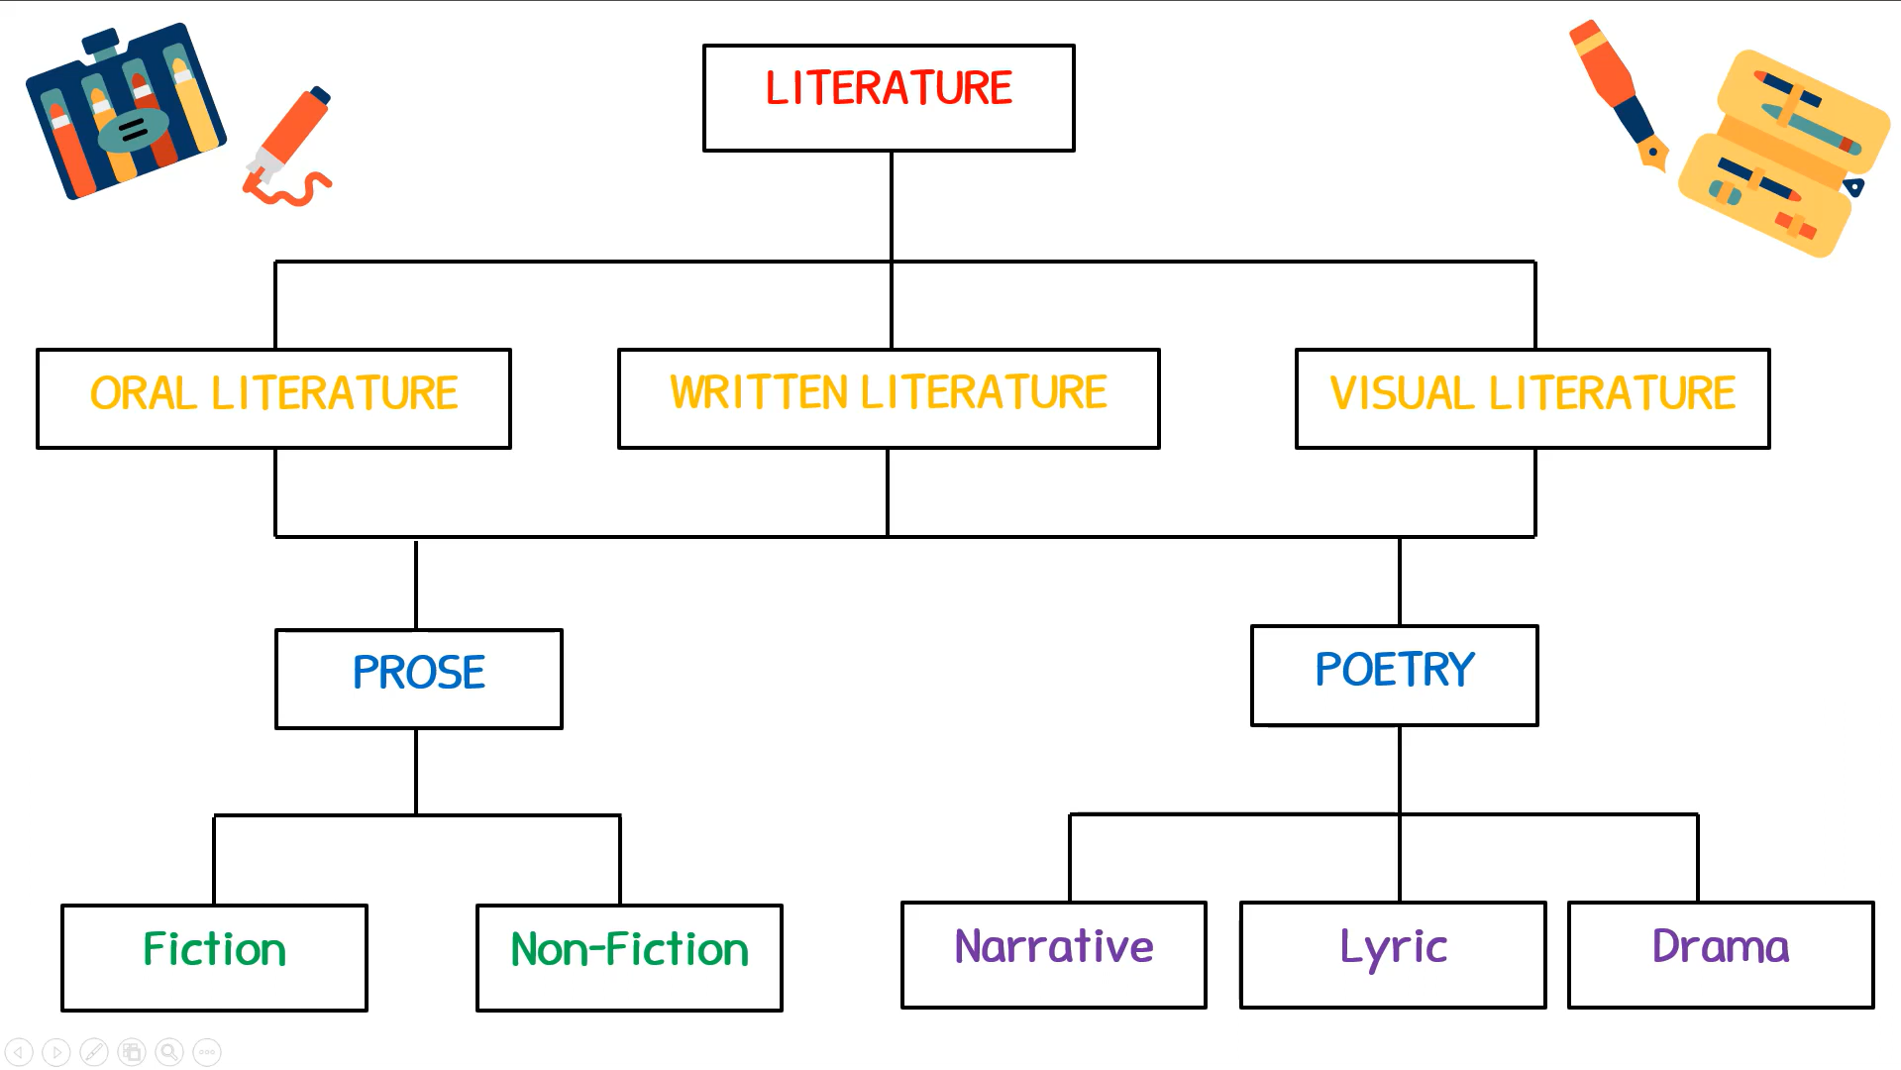

POSE
It is the most typical form of language, applying ordinary grammatical structure and natural flow of speech rather than rhythmic structure (as in traditional poetry).

SUBDIVISION OF PROSE
- Fiction
- Non-Fiction

FICTION
It is the form of any narrative or informative work that deals, in part or in whole, with information or events that are not factual, but rather, imaginary–that is, invented by the author.

LITERARY FORMS UNDER FICTION
F.N.F.P.L
- FAIRYTALE - Story about kings, queens, princes, and princesses with a magic touch of magic.
Example: Cinderella
- NOVEL - A long narrative with an organized plot usually with a maximum of 500 pages.
Example: PRIDE and PREJUDICE
- FABLES - Story that uses animals as characters and with moral lessons.
Example: AESOP’S FABLES
- PARABLES - Story used by Jesus in teaching the good news.
Example: The Prodigal Son
- LEGEND - A story about the origin of a place or a thing.
Example: Alamat ng Ampalaya

NON-FICTION
It is a form of any narrative, account, or other communicative work whose assertion and descriptions are understood to be factual.

LITERARY FORMS UNDER NON-FICTION
A.B.N.M.J
- AUTOBIOGRAPHY - Life story of a person written by himself.
Example: LONG WALK TO FREEDOM (The Autobiography of Nelson Mandela)
- BIOGRAPHY - Life story of a person written by another person.
Example: Steve Jobe by Walter Isaacson
- NEWSPAPER - Collection of news articles about various current events.
Example: INQUIRER
- MAGAZINE - Collection of articles regarding the lifestyle of man.
Example: YES! 2012 100 Most Beautiful Stars
- JOURNAL - Daily record of personal events.

POETRY
Is a form of literary art which uses the aesthetic qualities of language to evoke meanings in addition to, or in place of, the prosaic ostensible meaning.

SUBDIVISION OF POETRY
- Narrative
- Lyric
- Dramatic

NARRATIVE
It is a form of poetry which tells a story, often making use of the voices of a narrator and characters as well; the entire story is usually written in metered verse.

LITERARY FORMS UNDER NARRATIVE
E.B.M
- EPIC - A narrative poem about supernatural powers possessed by heroes and heroines.
Example: IL and AD and ODYSSEY HOMER
- BALLAD - A narrative poem with harmony and rhythm.
Example: EDGAR ALLAN POE’S ANNABEL LEE
- METRICAL ROMANCE - A narrative poem dealing with the emotions or phase of a life and the story is told in a simple, straightforward and realistic manner.
Example: Florante at Laura by Francisco Balagtas

LYRIC
Is a genre of poetry that expresses personal and emotional feelings, In the ancient world, lyric poems were sung, accompanied by a lyre. Lyric poems do not have to rhyme, and today do not need to be set to music or a beat.

LITERARY FORMS UNDER LYRIC
E.S.O
- ELEGY - A lament for the dead
Example: LYCIDAS by John Milton
- SONNET - A lyric poem consisting of 14 iambic pentameter lines.
- ODE - A lyrical poem praising or glorifying an event or individual, describing nature intellectually as well as emotionally.

DRAMATIC
It is the specific mode of fiction represented in performance.

Introduction
LITERATURE
- It is a body of work, either written, oral, or visual, containing imaginative language that realistically portrays thought, emotions, and experiences of the human condition.

IMPORTANCE OF LITERATURE
- Studying literature is like looking at the mirror of life where man’s experiences, his innermost feelings and thoughts are reflected.
- Through literature, we learn the culture of people across time and space.
- We understand not only the past life of a nation but also its present.
- We become familiar not only with the culture of neighboring countries but also with that of others living very far from us.

THE FOUR MAJOR CLASSIFICATIONS OF LITERATURE
- Prose
- Poetry
- Fiction
- Non-Fiction

THE LITERARY STANDARD ARE…
- These are a set of characteristics to determine whether or not a work is literary. The criteria was developed by writer William J. Long in his textbook “English Literature: Its History and Its Significance for the Life of the English-speaking World.”

THE LITERARY STANDARDS
- Universality - Great literature is timeless and timely. Forever relevant, it appeals to one and all, anytime, anywhere, because it deals with elemental feelings, fundamental truths and universal conditions.
- Artistry - It describes literature that is aesthetically appealing and reveals or conveys hidden truth and beauty. This type of literature appeals to broad audiences and possesses a sense of beauty in the writing that could even feel poetic.
- Permanence - A great work of literature endures. It can be read again and again as each reading gives fresh delight and new insights and opens a new world of meaning and experience. Its appeal is lasting.
- Style - This is the peculiar way in which writers see life, form his ideas and express them.
- Spiritual Value - Literature elevates the spirit by bringing out moral values which makes a better person. The capacity to inspire is part of the spiritual value of literature.
- Suggestiveness - This is associated with the emotional power of literature. Great literature moves us deeply and stirs our feeling and imagination, giving and evoking visions above and beyond the plane of ordinary life and experience.
- Intellectual Value - Intellectual works are relevant to society and thought provoking. Literature with intellectual value promotes critical thinking that enhances both abstract and reason-based thought processes and makes readers focus on the fundamental truths of life and nature.

PHILIPPINE LITERATURE OVER THE YEARS
- (BC-1564) : Pre-Colonial Period
- (1565-1863) : Spanish Colonization Period
- (1864-1896): Nationalistic/Propaganda and Revolutionary Period

PRE-COLONIAL PERIOD (BC-1564)
Characteristics:
- Based on oral traditions
- Crude on ideology and phraseology
Literary Forms:
- Oral Literature
- Folk Songs
- Folk Tales
- Epics
Oral LIterature
- Riddles - Battle of wits among participants
- Proverbs - Wise saying that contains a metaphor used to teach as a food for thought.
- Tanaga - A mono-riming heptasyllabic quatrain expressing insights and lessons on life.
Folk Songs
- Hele or Oyayi - A lullaby song
- Ambahan - A 7-syllable per line often that are about human relationships and social entertainment.
- Kalusan - Work songs that depict the livelihood of the people.
- Kanogan - Songs of lamentation of the dead.
Folk Tales
- Myths - Explain how the world was created, how certain animals process certain characteristics, why some places have waterfalls, volcanoes, mountains, flora or fauna.
- Legends - Explain the origin of things.
- Fables - Used an animal characters and allegory.
- Fanatic Stories - Deal with underworld characters such as “tiyanak”, “aswang”, “kapre”, and others.

SPANISH COLONIZATION PERIOD (1565-1863)
Characteristics:
- It has two distinct classifications: religious and secular
- It introduced Spanish as the medium of communication
Literary Forms:
- Religious Literature
- Secular Literature
Religious Literature - Religious lyrics written by Ladino poets or those versed in both Spanish and Tagalog were included in early catechism and were used to teach Filipinos the Spanish Language.
- Pasyon - A long narrative poem about the passion and death of Christ. The most popular was “Ang Mahal na Passion ni Jesu Cristong Panginoon Natin” by Aguino de Blen.
- Senakulo - Dramatization of the pasyon, it shows the passion and death of Christ.
Secular Literature
- Awit - Colorful tales of chivalry made for singing and chanting.
- Korido - Metrical tale written in octosyllabic quatrains.
- Prose Narratives - Written to prescribe proper decorum.

NATIONALISTIC/PROPAGANDA AND REVOLUTIONARY PERIOD (1864-1896)
Characteristics:
- Planted seeds of nationalism in Filipinos
- Language shifted from Spanish to Tagalog
- Addressed the masses instead of the “intellingentsia”
Literary Forms:
- Propaganda Literature
- Revolutionary Literature

AMERICAN COLONIAL PERIOD (1910-1945)
Period of Apprenticeship (1910-1930)
- Filipino Writers imitated English and American models.
- Poems written were amateurish and mushy, which phrasing and diction is awkward and artificial.
Period of Emergence (1920-1930)
- Highly influenced by Western literary trends like Romanticism and Realism.

JAPANESE OCCUPATION (1942-1960)
War Years (1942-1944)
- Tagalog poets broke away from the Balagtas tradition and instead wrote in simple language and free verse
- Fiction prevailed over poetry.
Period of Maturity and Originality (1945-1960)
- Bountiful harvest in poetry, fiction, drama, and essay.
- Filipino writers mastered English and familiarized themselves with diverse techniques.
- Literary “giants” appeared

CONTEMPORARY/MODERN PERIOD (1960-PRESENT)
Characteristics
- Martial Law repressed and curtailed human rights, including freedom of the press.
- Writer’s symbolisms and allegories to drive home their message, at the face of censorship.
- The theater was used as a vehicle for protest, such as the PETA (Philippine Educational Theater Association) and UP Theater.
- From the eighties onward, writers continue to show dynamism and innovation.

LITERARY APPROACHES
A Literary Approach is…
It is the evaluation of literary works. This includes the classification by genre, analysis of structure, and judgement of value.

FORMALISTIC OR LITERARY APPROACH
The study of the selection is more or less based on the so-called “literary elements”.

MORAL OR HUMANISTIC APPROACH
Literary is viewed to discuss man and its nature. It presents man as essentially rational; that is, endowed with intellect and free will; or that the piece does not misinterpret the true nature of man.

HISTORICAL APPROACH
Literature is seen both as a reflection and product of the times and circumstances in which it was written.

SOCIOLOGICAL APPROACH
Literature is viewed as the expression of man within a given social situation which is reduced to discussions on economy which will underscore the conflict between the two classes - the rich and the poor.

PSYCHOLOGICAL APPROACH
Literature is viewed as the expression of “personality” of “inner drives” or “neurosis”. It includes the psychology of the author, of the characters, and even the psychology of creation.

W2



POSE
It is the most typical form of language, applying ordinary grammatical structure and natural flow of speech rather than rhythmic structure (as in traditional poetry).

SUBDIVISION OF PROSE
- Fiction
- Non-Fiction

FICTION
It is the form of any narrative or informative work that deals, in part or in whole, with information or events that are not factual, but rather, imaginary–that is, invented by the author.

LITERARY FORMS UNDER FICTION
F.N.F.P.L
- FAIRYTALE - Story about kings, queens, princes, and princesses with a magic touch of magic.
Example: Cinderella
- NOVEL - A long narrative with an organized plot usually with a maximum of 500 pages.
Example: PRIDE and PREJUDICE
- FABLES - Story that uses animals as characters and with moral lessons.
Example: AESOP’S FABLES
- PARABLES - Story used by Jesus in teaching the good news.
Example: The Prodigal Son
- LEGEND - A story about the origin of a place or a thing.
Example: Alamat ng Ampalaya

NON-FICTION
It is a form of any narrative, account, or other communicative work whose assertion and descriptions are understood to be factual.

LITERARY FORMS UNDER NON-FICTION
A.B.N.M.J
- AUTOBIOGRAPHY - Life story of a person written by himself.
Example: LONG WALK TO FREEDOM (The Autobiography of Nelson Mandela)
- BIOGRAPHY - Life story of a person written by another person.
Example: Steve Jobe by Walter Isaacson
- NEWSPAPER - Collection of news articles about various current events.
Example: INQUIRER
- MAGAZINE - Collection of articles regarding the lifestyle of man.
Example: YES! 2012 100 Most Beautiful Stars
- JOURNAL - Daily record of personal events.

POETRY
Is a form of literary art which uses the aesthetic qualities of language to evoke meanings in addition to, or in place of, the prosaic ostensible meaning.

SUBDIVISION OF POETRY
- Narrative
- Lyric
- Dramatic

NARRATIVE
It is a form of poetry which tells a story, often making use of the voices of a narrator and characters as well; the entire story is usually written in metered verse.

LITERARY FORMS UNDER NARRATIVE
E.B.M
- EPIC - A narrative poem about supernatural powers possessed by heroes and heroines.
Example: IL and AD and ODYSSEY HOMER
- BALLAD - A narrative poem with harmony and rhythm.
Example: EDGAR ALLAN POE’S ANNABEL LEE
- METRICAL ROMANCE - A narrative poem dealing with the emotions or phase of a life and the story is told in a simple, straightforward and realistic manner.
Example: Florante at Laura by Francisco Balagtas

LYRIC
Is a genre of poetry that expresses personal and emotional feelings, In the ancient world, lyric poems were sung, accompanied by a lyre. Lyric poems do not have to rhyme, and today do not need to be set to music or a beat.

LITERARY FORMS UNDER LYRIC
E.S.O
- ELEGY - A lament for the dead
Example: LYCIDAS by John Milton
- SONNET - A lyric poem consisting of 14 iambic pentameter lines.
- ODE - A lyrical poem praising or glorifying an event or individual, describing nature intellectually as well as emotionally.

DRAMATIC
It is the specific mode of fiction represented in performance.

